Dear Substitute Teacher,

Thank you for filling in today! Students will be working on an artificial intelligence (AI) literacy project, exploring the advanced human-like language capabilities of ChatGPT, while learning to critically assess and derive meaningful insights from its responses.


This playbook provides step-by-step guidance for each stage of the lesson.

If you're interested in learning more about the topic, turn to the end of this playbook to find an optional section with additional background information and examples.

Thank you! 🤗



🚦Start Here:

- RECORD Attendance
- DISTRIBUTE ONE (1) Student Guide to each student

👋🏽 If students ask, “what are we doing” or “why are we doing this” say:

🎤Today, you're diving into the world of AI through a podcasting project that utilizes ChatGPT. Your teacher wants you to explore the capabilities and limitations of chatbots like ChatGPT. The goal is for you to experiment with emerging technology, learn more about how AI works, and consider its impact on information sharing. This is a chance to form your own opinions on AI's role in our lives and its potential future development.

- PROCEED with the option that works best for YOU:

Student-led |  | Teacher-led
Allow students to work independently on the activities outlined in the Student Guide. This option is suitable if students are capable of self-directed learning and time management. | OR | Follow the step-by-step instructions on the next page to lead students through the activities in the Student Guide. This option provides more structure and is recommended if students require additional support or guidance.

Teacher-led, step-by-step instructions start on the next page.
▼
Teacher-Led
Step-by-step instructions

Step 1 | Warm Up: Introduction to AI  Activating Prior Knowledge | ⏱️10 mins
- ASK students to fill out the Warm Up question on Page 1 (activity 3) of the Student Guide.

Optional Asks:
- Ask students to share what they already know about ChatGPT

TRANSITION TO NEXT STEP | 🎤Now, we’re going to see how well ChatGPT can talk like Ron from Harry Potter!

Step 2 | ChatGPT Demonstration  Evaluate characteristics of ChatGPT after a demonstration. | ⏱️15 mins
- DEMONSTRATE ChatGPT

DEMO OPTION A: If a computer and projector is available, go to 🔗chat.openai.com, LOGIN or SIGN UP to demo ChatGPT.

Enter this prompt: I want you to act like Ron from Harry Potter. I want you to respond and answer like Ron using the tone, manner and vocabulary he would use. Do not write any explanations. Only answer like Ron. You must know all of the knowledge of Ron. My first sentence is "Hi Ron."

Give students an opportunity to share-out questions they want to ask “Ron.” Prompt ChatGPT with their questions to demonstrate ChatGPT’s capabilities.

DEMO OPTION B: If a live demonstration is not possible, ask students to review the example shown on Page 2 of the Student Guide (activity 5).

- ASK students to discuss in groups:
  - How natural does ChatGPT sound and why?
TRANSITION TO NEXT STEP | 🎤Now we’re going to get even more familiar with ChatGPT. Test it out using your own prompts to figure out what it’s good at and isn’t. You’ll be interviewing ChatGPT for a podcast project later, so it’s important to know what it will and won’t respond well to.

Step 3 | Hands-On ChatGPT Lab  Test out the limitations of ChatGPT through various prompts. | ⏱️45 mins
- DIRECT students to Pages 3-5 of the Student Guide (activities 7-12) to try ChatGPT for themselves and reflect on the results.

⏰Allocate about 5-10 minutes for students to get logged in and start playing with ChatGPT. After a few minutes of open play, encourage progress on the reflection questions in the Student Guide.
TRANSITION TO NEXT STEP | 🎤We’re going to create a podcast, interviewing ChatGPT! When you record the podcast, one person will act as the host by reading the questions you come up with. The other person will pretend to be a person, but will actually be reading the responses from ChatGPT!

Step 4 | Podcast Project Part I  Write the script | ⏱️60 mins
- PAIR UP students for the podcast project.

- DIRECT students to Pages 6-7 of the Student Guide (activities 13-16) where they will follow steps to write a podcast script.

For those that finish early:
- Suggest additional podcast segments that they can create, such as a quiz, audience call-in, or a commercial break.

Optional Asks:
- Ask students to share what prompts they used.
- Ask students to share what they see as ChatGPT’s strengths and weaknesses.
Step 5 | Podcast Project Part II  Record the podcast | ⏱️3 hrs
- DIRECT students to Pages 8-9 of the Student Guide (activity 17) where they will follow steps to record their podcast script.

Recommended pacing:
- Set up a Spotify podcast account on their laptops or mobile app, and watch a video guide on creating a podcast. (30 minutes)
- Record clips of their intros, question and answers, and outro reflection. (1 hour)
- Give the episode a name and description, add transitions or music, and then publish their episodes. (30 minutes)

For students needing more technical assistance, direct them to the resources on Page 9 of the Student Guide.
Step 6 | Closing Reflection  Compare and contrast the role of AI and humans in information-providing roles | ⏱️15 mins
- DIRECT students to complete the reflection questions on Pages 9-10 of the Student Guide (activities 18-19).

Optional:
- Invite the students to share their podcast links with each other, family and friends!
- Ask students what surprised them about using ChatGPT for their podcast interviews.

🏁Step-by-step instructions end here.

🤿Diving Deeper: Check out the next page for (optional) background information and examples on the lesson topic.

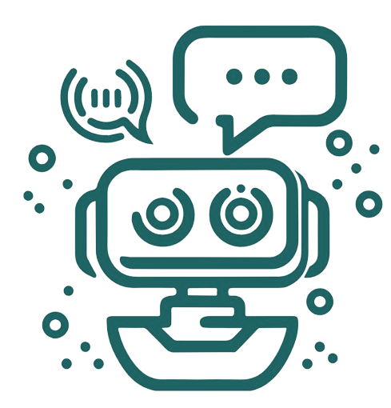
For Your Information (optional)
Background and further reading

The Point: While AI that produces human-like language has improved significantly in recent years, it’s still up to humans to use the text, evaluate its truthfulness, and decide whether it’s meaningful.

ChatGPT is an artificial intelligence chatbot that has taken the world by storm–It can write poems, computer code, cite sources in an essay and solve math problems. But how helpful is it? What are its limitations?

What is ChatGPT and how does it work?
- ChatGPT is a generative AI tool that can generate original text, images, and sound by responding to conversational text prompts
- It can write poems, computer code, cite sources in an essay and solve math problems
- ChatGPT is trained on millions of web pages and digital documents, based on its training, it calculates a best “guess” response

How much is ChatGPT impacting education?
- New norms and rules are being created for using this emerging technology in the classroom. Such as, enforcing handwritten assignments, monitoring computer activity, using AI writing detectors, and incorporating the AI into lessons for critical evaluation.
- Students are encountering varied perceptions of generative AI: some schools consider the usage to be academic misconduct, while other students may be encouraged or required to use it (depending on the context).
How are schools setting boundaries around how students use it?
- Alarmed by A.I. Chatbots, Universities Start Revamping How They Teach (Jan 2023, New York Times)
- What Students Are Saying About ChatGPT (Feb 2023, New York Times)
- ChatGPT in Education: The Pros, Cons and Unknowns in Generative AI (March 2023, EdTech)
- Inside ChatGPT: How AI Chatbots Work (May 2023, NBC News)
